CHAPTER 2:
ENTREPRENEURIAL MOTIVATION
AND COMPETENCIES
Learning Outcomes
1. Explain the key entrepreneurial motivation 2. Explain the competencies of successful entrepreneurs
INTRODUCTION
❑ Success of an entrepreneur depends on his willingness to commit to the thing that he does.
❑ Entrepreneurs with high motivation will pursue entrepreneurial opportunities towards entrepreneurial processes.
❑ one should be able to identify his strengths and weaknesses.
❑ Therefore, motivation plays a vital factor in amplifying his strength, so he may be able to survive in the indeterminate environment.
ENTREPRENEURIAL MOTIVATION
❑ Motivation is the process of internal and external enthusiasm and persistence to pursue all efforts toward achieving goals to satisfy personal needs (Gray & Starke, 1988; Robbins, Coulter, & De Cenzo, 2014).
❑ Entrepreneurial motivation is the process of converting an individual who can create new opportunities to achieve fortune and economic development.
Motivation Theories
1. Abraham Maslow’s Theory of Needs 2. Hertzberg’s Two-Factor Theory
3. Douglas Mc Gregor’s Theory X and Theory Y
Abraham Maslow’s Theory of Needs 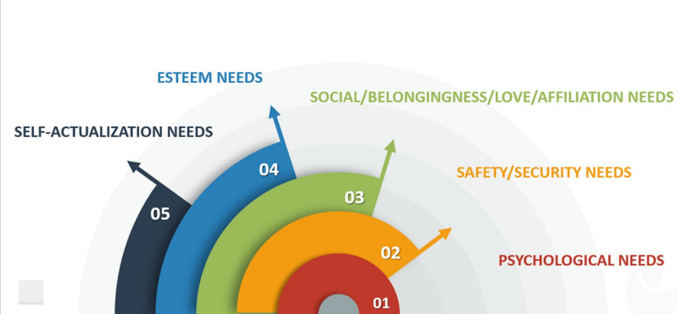PHYSIOLOGICAL NEEDS
THEORY OF NEEDS
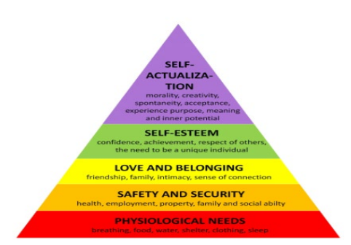
❑ Model for understanding the
motivations for human behavior.
❑ Humans are highly motivated in
order to fulfill their needs, which is
based on hierarchical order.
❑ If some of our most important
needs are unmet, we may be
unable to progress and meet our
other needs. This can help explain
why we might feel "stuck" or
unmotivated.
Hertzberg’s Two Factor Theory

❑ There are certain factors in the
workplace that cause job
satisfaction while a separate
set of factors cause
dissatisfaction, all of which act
independently of each other.
❑ Satisfaction & dissatisfaction
at work are influenced by two
sets of factors: hygiene factors
and motivators.
Douglas Mc Gregor’s - Theory X & Theory Y
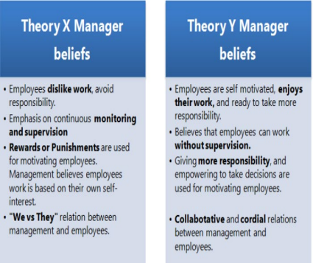
❑ Two aspects of human behaviour
at work - one of which is negative,
called as Theory X and the other
is positive, Theory Y.
❑ Theory X explains the importance
of heightened supervision,
external rewards, and penalties,.
❑ Theory Y highlights the motivating
role of job satisfaction and
encourages workers to approach
tasks without direct supervision
PERSONAL ENTREPRENEURIAL COMPETENCIES (PECS)
• Key characteristics that should be possessed by successful entrepreneurs.
• Required- to perform entrepreneurial functions effectively.
• McBer and McClelland (1985) have listed out 13 entrepreneurial competencies that must be possess.
McClelland and McBer (1985)
Initiative
Sees and Acts on
Opportunities Persistence
Information Seeking
Maintaining High Quality Work
Commitment to Work
Contract
Efficiency Orientation
Systematic Planning
Problem
Solving
Self-confidence Assertiveness Persuasion
Use of
Influence Strategies
Entrepreneurial Competencies
McClelland and McBer (1985)
1. Initiative
The entrepreneur should be able to take actions that go beyond his job requirements and to act faster. He is always ahead of others and able to become a leader in the field of business.
Examples
▪ Does things before being asked or compelled by the situation. ▪ Acts to extend the business into new areas, products or services
Entrepreneurial Competencies
McClelland and McBer (1985)
2. Sees and acts on opportunities
An entrepreneur always looks for and takes action on opportunities.
Examples
▪ Sees and acts on new business opportunities ▪ Seizes unusual opportunities to obtain financing, equipment, land, work space or assistance
Entrepreneurial Competencies
McClelland and McBer (1985)
3. Persistence
An entrepreneur is able to make repeated efforts or to take different actions to overcome an obstacle that get in the way of reaching goals.
Examples
▪ Takes repeated or different actions to overcome an obstacle ▪ Takes action in the face of a significant obstacle
Entrepreneurial Competencies
McClelland and McBer (1985)
4. Information Seeking
An entrepreneur is able to take action on how to seek information to help achieve business objectives or clarify business problems.
Examples
▪ Does personal research on how to provide a product or service ▪ Consults experts or experienced persons to get relevant information ▪ Seeks information or asks questions to clarify a client's or a supplier's need
▪ Personally undertakes market research, analysis or investigation ▪ Uses contacts or information networks to obtain useful information
Entrepreneurial Competencies
McClelland and McBer (1985)
5. Concern for High Quality of Work
An entrepreneur acts to do things that meet certain standards of excellence which gives him greater satisfaction.
Examples
▪ States a desire to produce or sell a top or better quality product or service
▪ Compares own work or own company's work favorably to that of others
Entrepreneurial Competencies
McClelland and McBer (1985)
6. Commitment to Work Contract
An entrepreneur places the highest priority on getting a job completed.
Examples
▪ Makes personal sacrifice or expends extraordinary effort to complete a job
▪ Accepts full responsibility for problems in completing a job for customers
▪ Pitches in with workers or works in their place to get the job done ▪ Expresses a concern for satisfying the customer
Entrepreneurial Competencies
McClelland and McBer (1985)
7. Efficiency Orientation
A successful entrepreneur always finds ways to do things faster or with fewer resources or at a lower cost.
Examples
▪ Looks for or finds ways to do things faster or at less cost ▪ Uses information or business tools to improve efficiency ▪ Expresses concern about costs vs. benefits of some improvement, change, or course of action
Entrepreneurial Competencies
McClelland and McBer (1985)
8. Systematic Planning
An entrepreneur develops and uses logical, step-by-step plans to reach goals.
Examples
▪ Plans by breaking a large task down into sub-tasks ▪ Develops plans that anticipate obstacles
▪ Evaluate alternatives
▪ Takes a logical and systematic approach to activities
Entrepreneurial Competencies
McClelland and McBer (1985)
9. Problem Solving
Successful entrepreneur identifies new and potentially unique ideas to achieve his goals.
Example
▪ Switches to an alternative strategy to reach a goal ▪ Generates new ideas or innovative solutions
Entrepreneurial Competencies
McClelland and McBer (1985)
10.Self-Confidence
A successful entrepreneur has a strong belief in self and own abilities.
Examples
▪ Expresses confidence in own ability to complete a task or meet a challenge
▪ Sticks with own judgment in the face of opposition or early lack of success
Entrepreneurial Competencies
McClelland and McBer (1985)
11. Assertiveness
An entrepreneur confronts problems and issues with others directly.
Examples
▪ Confronts problems with others directly
▪ Tells others what they have to do
▪ Reprimands or disciplines those failing to perform as expected
Entrepreneurial Competencies
McClelland and McBer (1985)
12. Persuasion
An entrepreneur can successfully persuade or influence others for mobilizing resources, obtaining inputs, organizing productions and selling his products or services.
Examples
▪ Convinces someone to buy a product or service ▪ Convinces someone to provide financing
▪ Convinces someone to do something else that he would like that person to do
Entrepreneurial Competencies
McClelland and McBer (1985)
13. Use of Influence Strategies
An entrepreneur is able to make use of influential people to reach his business goals.
Examples
▪ Acts to develop business contracts
▪ Uses influential people as agents to accomplish own objectives ▪ Selectively limits the information given to others ▪ Uses a strategy to influence or persuade others
SUMMARY
❑ High achievement of motivation is necessary to be a successful entrepreneur.
❑ Therefore, entrepreneurs need to have clear goals. ❑ In the early stage of developing the business, entrepreneurs must be highly motivated to face the risk of starting the enterprise.


